BSCS FINAL PROJECT

MODEL UNITED NATION APP
PREP-MUN



Project Advisor

DR RABIA TEHSEEN

Presented by:
Group ID: S24CS012

Student Reg# Student Name
L1S21BSCS0210 HAMZA BASHARAT
L1S21BSCS0212 ARQAM ALTAF
L1S21BSCS0175 AHMAR AKHTAR

Faculty of Information Technology

University of Central Punjab
Complete System
SDP Phase IV

MODEL UNITED NATIONS APP - PREPMUN
Advisor: Dr. Rabia Tehseen

Team S24CS012
Member Name | Primary Responsibility
Arqam Altaf | Software Development
Hamza Basharat | Documentation
Ahmer Akhtar | Maintenance

Table of Contents
Table of Contents i
Revision History ii
Abstract iii
1. Introduction 1
1.1 Product 1
1.2 Background 1
1.3 Objective(s)/Aim(s)/Target(s) 1
1.4 Scope 1
1.5 Business Goals 1
1.6 Document Conventions 1
1.7 Miscellaneous 1
2. Technical Architecture 2
2.1 Application and Data Architecture 2
2.2 Component Interactions and Collaborations 3
2.3 Design Reuse and Design Patterns 3
2.4 Technology Architecture 3
2.5 Architecture Evaluation 3
3. Detailed/Component Design 4
3.1 Component-Component Interface 4
3.2 Component-External Entities Interface 4
3.3 Component-Human Interface 4
4. Screenshots/Prototype 4
4.1 Workflow 4
4.2 Screens 4
4.3 Additional Information 4
5. Other Design Details 5
6. Test Specification and Results 5
6.1 Test Case Specification 5
6.2 Summary of Test Results 6
7. Project Completion Status 6
8. Deployment/Installation Guide 7
9. User Manual 7
10. References 7
11. Project Summary Form 8
Appendix A: Glossary 11
Appendix B: IV & V Report 12

Revision History
Name | Date | Reason For Changes | Version

Abstract
Model United Nations (MUN) conferences serve as a platform for students to engage in debates and discussions about global issues, enhancing their public speaking, diplomacy, and research skills. However, students often face challenges in preparation due to the lack of accessible and organized resources. This mobile application aims to address this gap by providing a comprehensive solution tailored to the needs of the MUN community, particularly in Pakistan.
The proposed MUN Prep Mobile Application will be a first-of-its-kind platform designed to assist students in preparing for their competitions effectively. It will include features such as an AI-powered chatbot for query resolution, delegate registration, agenda-specific databases, payment gateways, and forums for community interaction. Additionally, it will offer curated resources to help users understand the topics and agendas across various MUN domains, such as Security Council, NGOs, and Press Committees.
As active participants in Pakistan's MUN circuit, we aim to create a tool that enhances accessibility, fosters engagement, and supports the growth of MUN culture within the region. By streamlining preparation and fostering collaboration among participants, this application has the potential to transform the MUN experience for students and organizers alike.

Introduction

Product

Introducing prep-mun, the ultimate mobile application for Model United Nations enthusiasts! PREP-MUN is designed to streamline your MUN experience, offering features like real-time schedule updates, committee assignments, document sharing, and networking opportunities with fellow delegates. Stay informed with live news feeds and alerts, participate in interactive polls and debates, and access a comprehensive library of MUN resources right at your fingertips. Whether you’re a seasoned delegate or new to MUN, PREP-MUN ensures you're always prepared and connected, making every conference more productive and engaging.

Background
The Model United Nations (MUN) mobile application is designed to revolutionize the MUN experience by providing delegates, chairs, and organizers with a comprehensive digital platform. This app facilitates seamless communication, document sharing, and real-time updates, ensuring participants remain informed and engaged throughout conferences. With features such as an integrated schedule, resolution drafting tools, and a moderated chat system, the MUN app enhances collaboration and efficiency, allowing users to focus on diplomacy and debate. Additionally, it offers educational resources and tutorials to support both novice and experienced delegates in honing their skills, making it an indispensable tool for anyone involved in MUN

Objective(s)/Aim(s)/Target(s):
Aims and Objectives for Model United Nations Mobile Application:
Enhance Engagement:
- Facilitate real-time communication and collaboration among delegates.
- Provide interactive tools and resources for delegates to actively participate in MUN activities.

Streamline Information:
- Centralize all relevant MUN information, including schedules, agendas, and delegate lists.
- Offer easy access to background guides, country profiles, and resolution templates.

Improve Accessibility:
- Ensure the app is user-friendly and accessible on various mobile platforms.
- Include features such as text-to-speech and adjustable text sizes for inclusivity.

Foster Networking:
- Enable delegates to connect and interact through built-in social and messaging features.
- Create a platform for networking with delegates from different regions and backgrounds.

Enhance Learning:
- Provide educational resources, such as articles, videos, and tutorials, to improve understanding of MUN procedures and topics.
- Include quizzes and interactive exercises to reinforce learning and preparation.

Support Delegation Management:
- Allow delegation heads to manage their teams, track participation, and distribute tasks.
- Facilitate smooth registration and attendance tracking for conferences.

Real-time Updates:
- Offer push notifications for important announcements, schedule changes, and news updates.
- Provide live updates on committee proceedings and voting results.

Encourage Participation:
- Gamify the MUN experience with badges, points, and leaderboards to motivate active involvement.
- Organize virtual events and simulations to keep delegates engaged between conferences.

Feedback and Improvement:
- Collect feedback from users to continuously improve the app’s functionality and user experience.
- Implement regular updates and new features based on user input and technological advancements.

Promote Sustainability:
- Reduce paper usage by digitizing documents and resources.
- Encourage eco-friendly practices within the MUN community through app features and information

Scope
The scope of the Model United Nations (MUN) mobile application encompasses providing a comprehensive platform for participants to enhance their MUN experience. This app will offer features such as real-time updates on conference schedules, delegate directories, committee documents, and resolution tracking. It will facilitate seamless communication through instant messaging and discussion forums, and provide resources like study guides, position paper templates, and MUN rules and procedures. Additionally, it will include tools for networking, such as social media integration and event announcements, ensuring delegates remain informed and engaged throughout the conference.

Business Goals
• Enhance User Engagement and Experience:
- Develop intuitive and user-friendly interfaces to facilitate easy navigation and access to features.
- Integrate interactive elements like real-time chat, forums, and live polls to foster active participation.
- Provide personalized content and notifications to keep users informed and engaged with relevant updates and events.
• Expand User Base and Market Reach:
- Implement targeted marketing strategies to attract new users, including students, educators, and MUN enthusiasts.
- Establish partnerships with educational institutions and MUN organizations to increase visibility and credibility.
- Offer multilingual support to cater to a diverse global audience and enhance accessibility.
• Generate Sustainable Revenue Streams:
- Introduce premium features and subscription models to provide additional value for dedicated users.
- Leverage advertising and sponsorship opportunities with relevant brands and organizations.
- Develop merchandise and event ticket sales within the app to create supplementary income avenues.

Document Conventions
Heading: Font-size: 14
- Font Style: Times New Roman
- Style: BSubheading:
- Font-size: 12
- Font Style: Times New Roman
- Style: Bold

Content:
- Font size: 12
- Font Style: Times New Roman
Style: Simple

Miscellaneous
The MUN mobile application also includes additional features designed to enhance the user experience, such as customizable notifications for important updates, a glossary of commonly used MUN terms, a feedback section for continuous improvement, and a resource library with access to previous conference materials and guides. These tools aim to provide delegates with all the necessary information and support to ensure a successful and engaging MUN experience.

Technical Architecture
- Is the system custom-built? COTS?
The system is custom-built, specifically designed to cater to the unique needs of Model United Nations (MUN) participants and organizers, and is not a Commercial Off-The-Shelf (COTS) product.
- What type of processing is the current system responsible for?
- Batch and/or online
- Transaction processing and/or analytical reporting
The system primarily handles real-time online processing, ensuring immediate responses to user queries and updates. Some batch processing may be used for analytical purposes, such as improving chatbot responses or tracking user engagement.
The system operates mainly in an online environment for real-time functionality. Batch processing is implemented in the backend for processing data logs, such as usage analytics and chatbot optiization.
- What are the major application components?
- Frontend: Built using Flutter for a user-friendly mobile interface.
- Backend Services: Firebase Functions and AI chatbot frameworks like OpenAI GPT.
- Database: Firebase Firestore for structured data and Firebase Cloud Storage for documents.
Admin Portal: A web-based platform for managing conference details and chatbot updates.

- What data does the current system collect and manage?
User profiles (e.g., delegate information, preferences).
Chat logs (e.g., user interactions with the chatbot).
Knowledge base (e.g., agenda-specific data, position paper templates).
Conference materials (e.g., schedules, guides, and resources).

- What is the basic application architecture (layered, client/server, etc.)?
The system follows a layered architecture, consisting of:
Presentation Layer (Frontend app and admin portal).
Business Logic Layer (Firebase Functions and chatbot).
Data Layer (Firestore and Cloud Storage).

- What programming language is the current system built in?
The frontend is built in Dart (using Flutter), and the backend uses JavaScript/TypeScript for Firebase Functions.

- What is the hardware platform that supports the current system?
The system is hosted on Google Firebase, leveraging its cloud infrastructure to ensure reliability and scalability.

- What database platform supports the current system?
Firebase Firestore serves as the primary database for structured data, and Firebase Cloud Storage and SQL handles large file uploads and resources.

- Does the system have an end-user interface? If so, what type of user interface? (e.g., browser based, thick client)?
Yes, the system includes:
A mobile app interface for end-users (delegates and participants).
A browser-based admin portal for MUN organizers and administrators.
- What is the basic network architecture (e.g., available on LAN, WAN, Internet)?
The system is Internet-based, accessible globally, ensuring real-time connectivity for users and administrators.
- Where is the system hosted (e.g., Enterprise Data Center, Other CMS Data Center, External Data Center)?
The system is hosted on Google Firebase, a reliable external cloud hosting platform, ensuring seamless performance and global accessibility.

Application and Data Architecture
Component Diagram:

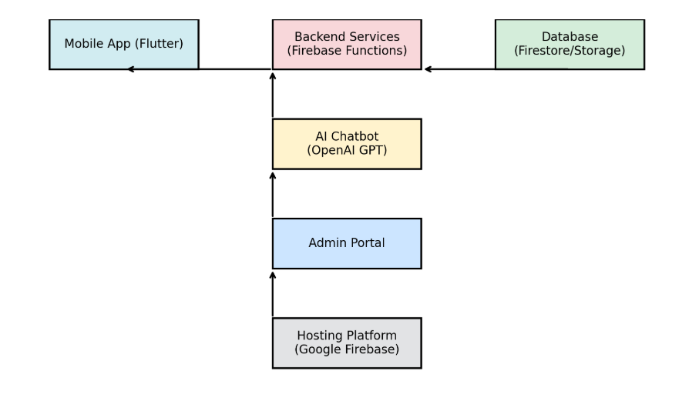
Mobile App (Flutter): The client-facing application where users interact with the app's features.
Backend Services (Firebase Functions): Handles server-side logic, user authentication, and communication with other components.

Database (Firestore/Storage): Stores user data, resources, and other app-related information.

AI Chatbot (OpenAI GPT): Processes user queries related to committees and topics.

Admin Portal: Manages administrative tasks, such as conference details, user queries, and updates.

Hosting Platform (Google Firebase): Hosts backend services and database for the app.
FLOW CHART:

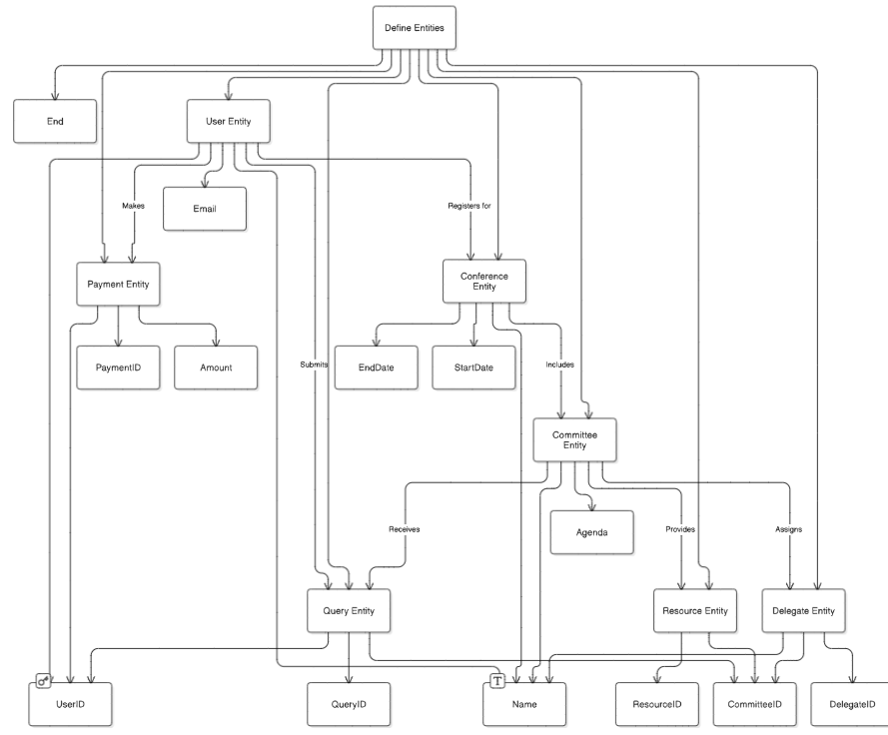

Class diagram:

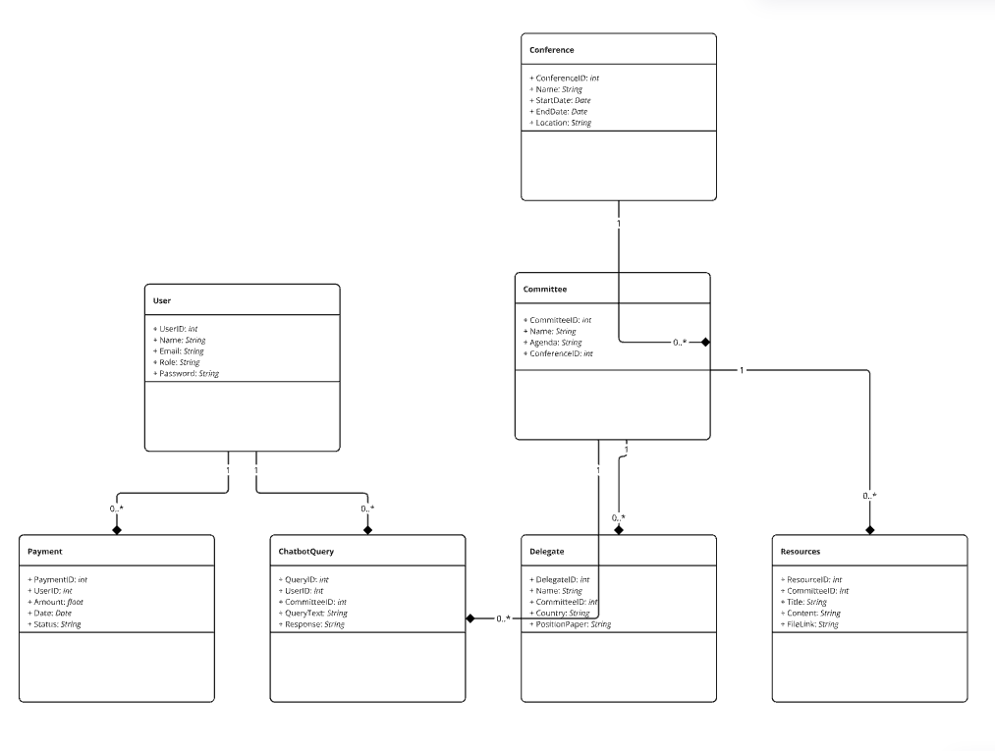
Relationships:
User has many ChatbotQueries (1:M)
User can make many Payments (1:M)
Conference can have multiple Committees (1:M)
Committee can include many Delegates (1:M)
Committee can provide many Resources (1:M)
Delegate submits queries to the Chatbot (M:1)

Decision Table:

Conditions | delegates | chair | organizers
Access resources | yes | yes | yes
Make payment | yes | No | No
Position paper | yes | No | No
Manage committee | No | Yes | Yes
Send chatbot query | Yes | No | No
Manage payment | No | No | Yes
View delegates | No | No | Yes
Create conference | No | No | Yes
Generate report | Yes | Yes | No
Update user | No | No | Yes
Modify conference | No | No | Yes
Country allotment | No | Yes | Yes
Personality allotment | No | Yes | Yes
Committee allotment | No | Yes | Yes

Register for Conference: All user types (Delegate, Chair, Organizer) can register for the conference, but Delegates may need approval or assignment to a committee.

Access Resources: All users can access resources (e.g., background guides, research materials) related to their committees or topics.

Make Payment: Only Delegates and Organizers can make payments (e.g., for registration fees), while Chairs typically do not handle payments.

Submit Position Paper: Only Delegates can submit position papers, a critical aspect of preparation for the conference.

Create/Manage Committees: Only Chairs and Organizers can create or manage committees for the conference.

Assign Delegate to Committee: Chairs and Organizers can assign Delegates to committees during conference preparation.

Send Chatbot Query: All user types can send queries to the Chatbot for help or information about conference details, committee topics, etc.

View Chatbot Response: All users can view responses from the Chatbot.

Manage Payments: Organizers can manage payments, ensuring that all delegates have completed payment for the conference.

View Delegates/Participants: Chairs and Organizers can view the list of delegates and participants in a committee, while Delegates cannot.

Create Conference: Only Organizers can create conferences within the app.

Generate Reports: Chairs and Organizers can generate reports on delegates, conference progress, and committee activities.

Update User Profile: All users can update their profiles (e.g., contact details, position, etc.).

Modify Conference Details: Only Organizers can modify conference details like dates, location, etc.Register for Conference: All user types (Delegate, Chair, Organizer) can register for the conference, but Delegates may need approval or assignment to a committee.

Access Resources: All users can access resources (e.g., background guides, research materials) related to their committees or topics.

Component Interactions and Collaborations

DFD:
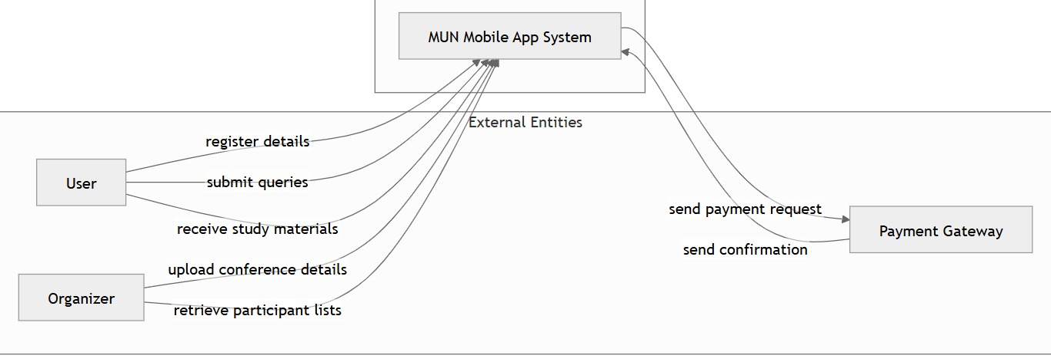
0 LEVEL:

Delegate: Participates in the conference, submits position papers, makes payments, etc.
Chair: Manages committees, views delegates, and handles queries.
Organizer: Manages the conference, payments, and generates reports.
External System (e.g., Payment Gateway, Chatbot Service): External systems integrated with the application, like payment processing and chatbot services.

DFD:
1st LEVEL:

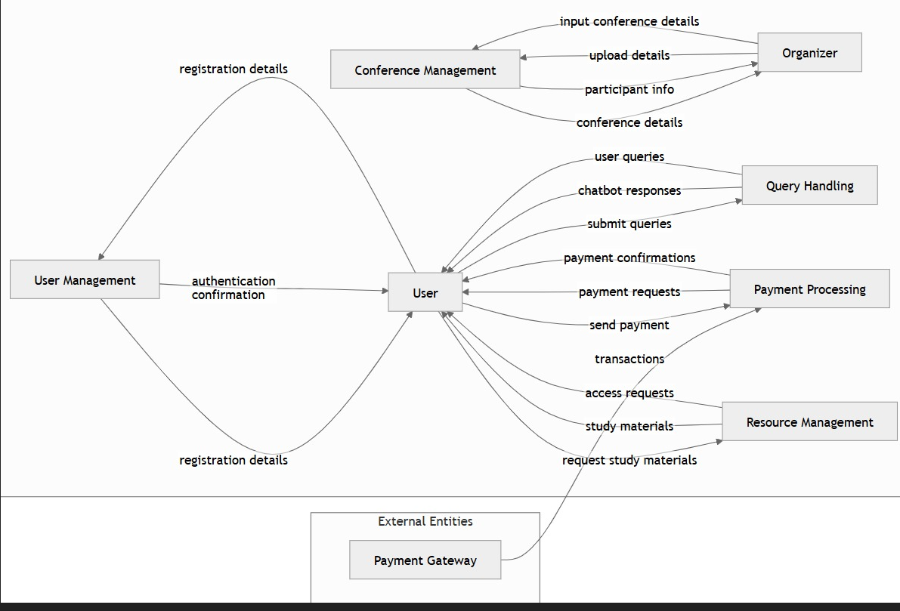

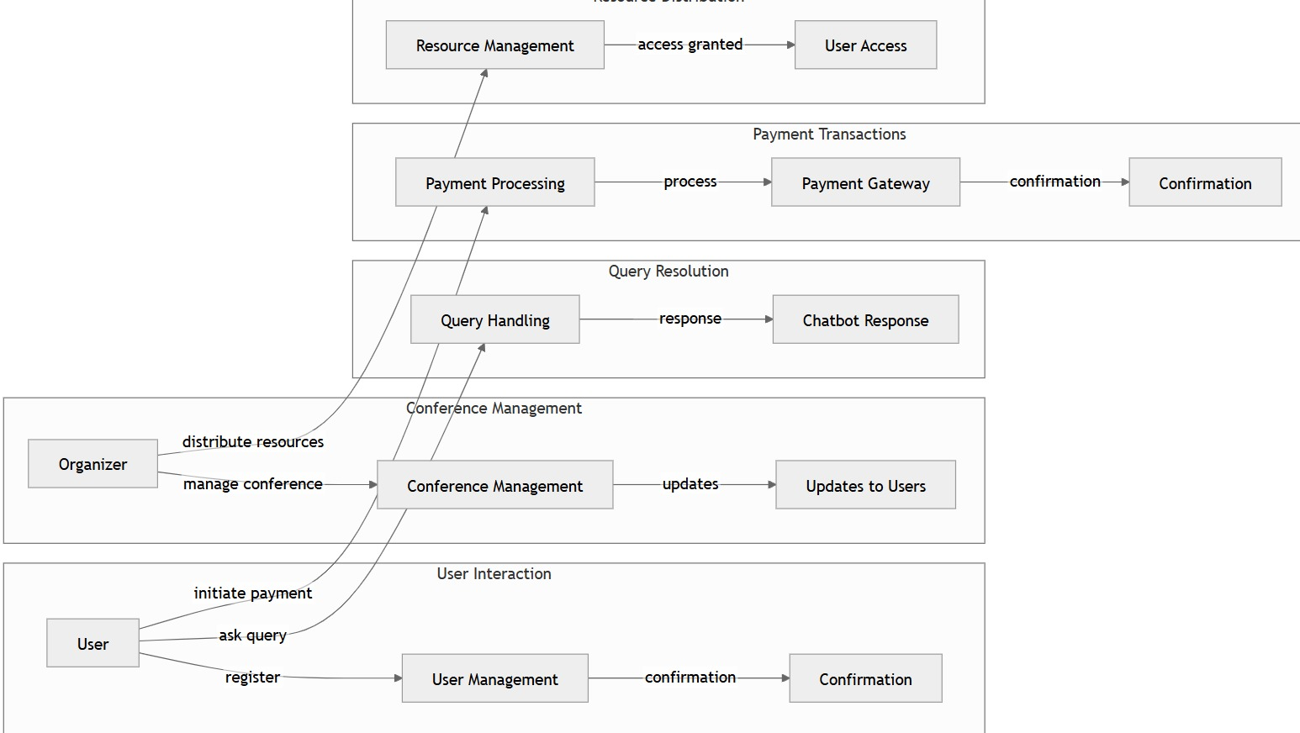

r to User Management: Sends registration details and receives authentication confirmation.
User to Resource Management: Requests and retrieves study materials.
User to Query Handling: Submits queries and receives chatbot responses.
User to Payment Processing: Sends payment requests and receives confirmations.
Organizer to Conference Management: Uploads conference details and receives participant

ACTIVITY DIAGRAM:

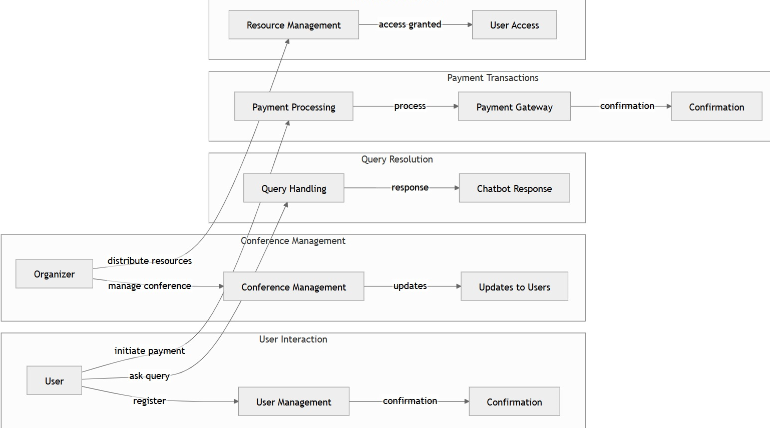

Key Activities in the MUN Ap

User Registration and Login:
- User opens the app.
- Chooses to register or log in.
- Provides credentials.
- System validates credentials.
- Access granted or denied.

Conference Participation:
- User selects a conference.
- Registers for the conference.
- Pays the required fee.
- Gets assigned to a committee.
- Accesses resources or submits position papers.

Query Resolution via Chatbot:
- User types a question.
- Chatbot processes the query.
- Fetches the answer from relevant data.
- Provides the response.

Payment Workflow:
- User initiates a payment.
- Enters payment details.
- System processes the payment via the payment gateway.
- Receives confirmation or error message.

Elements of the Activity Diagram
- Start and End Nodes: Represent the beginning and conclusion of the process.
- Activities: Tasks or actions performed by users or the system.
- Decision Points: Indicate conditional branches in the workflow.
- Swimlanes: Divide actions among actors (users, system components, external systems).
Transitions/Arrows: Show the flow of control between activities >

Design Reuse and Design Patterns

Design Reuse
The app can reuse pre-built authentication modules (e.g., Firebase Authentication), payment gateways, and chatbot frameworks to streamline development and ensure reliability.

Design Patterns
Model-View-Controller (MVC): Separates the app's UI, logic, and data handling for better maintainability.
Observer Pattern: To manage real-time updates like notifications for schedule changes or announcements.
Singleton Pattern: For managing a single instance of resources like the chatbot service or database connection.

Technology Architecture
The technology architecture of the MUN mobile application is designed to provide a scalable, secure, and user-friendly platform tailored for Model United Nations participants. The app is built using Flutter for cross-platform development, ensuring seamless deployment on both Android and iOS devices. Backend services are powered by Firebase, utilizing its real-time database for dynamic content management, Firebase Authentication for secure user login, and Cloud Firestore for storing structured data. Notifications are managed through Firebase Cloud Messaging, while Google Cloud provides a robust hosting environment. The system adopts a client-server architecture, where the mobile client communicates with the backend via REST APIs. Additionally, high-fidelity UI/UX designs created in Figma ensure an intuitive and engaging user experience. The architecture supports integration of external APIs for payment gateways and chatbot functionalities, employing modular and layered design patterns to maintain flexibility, maintainability, and scalability.

Architecture Evaluation
The architecture of the MUN mobile app is evaluated based on its scalability, usability, security, performance, and cost-effectiveness. Built with Flutter and Firebase, it ensures cross-platform support, real-time updates, and scalability to handle an increasing user base. The app's modular and layered architecture, enhanced by design patterns like MVC, supports maintainability and extensibility for future features. Security is prioritized through Firebase Authentication and TLS/SSL encryption for secure data and payment transactions. The intuitive interface, designed with Figma, enhances usability and inclusivity. While leveraging Firebase minimizes infrastructure costs, dependency on its services may lead to potential cost escalations with user growth. Overall, the architecture strikes a balance between functionality, adaptability, and reliability, making it well-suited for the dynamic needs of the MUN community.

Detailed/Component Design

Component-Component Interface
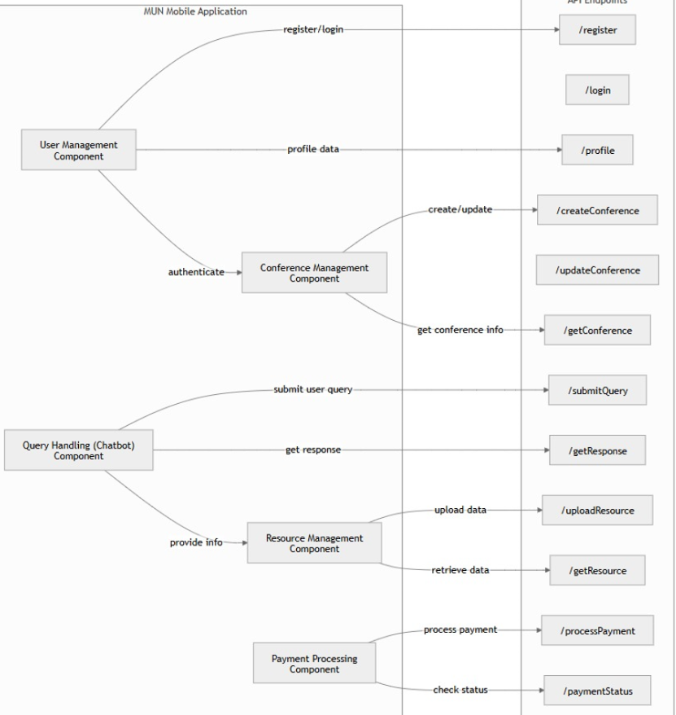

Component-External Entities Interface:

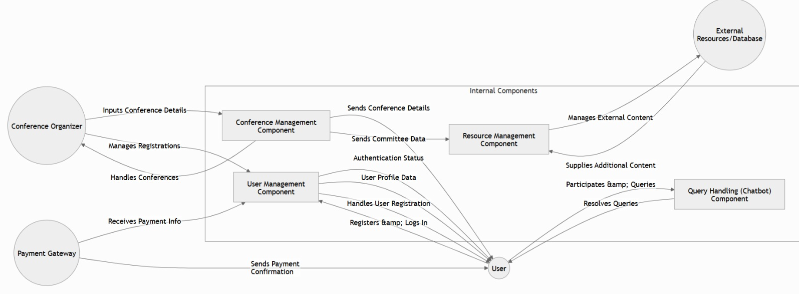

Component-External Entities Interface

Component-Human Interface
The Component-Human Interface in the MUN mobile app bridges user interactions with system components, providing an intuitive and efficient experience for various stakeholders, including delegates, organizers, and chairs. Key details include:

User Interface (UI):
- Design Tools: The UI is designed using Figma, focusing on modern, user-friendly, and accessible layouts that cater to both experienced and novice users.
- Features:
  - Navigation: Intuitive menu systems for easy access to features like committee details, resources, and chatbot queries.
  - Customizable Notifications: Users can set preferences for updates related to their committees or conference schedules.
  - Dashboard: A personalized dashboard displays key updates, schedules, and tasks for delegates.

Input Mechanisms:
- Touch-Based Interaction: Users interact with the app using touch gestures for seamless navigation and operation.
- Forms: Delegates use forms for registration, payment, and submission of position papers.

Output Mechanisms:
- Real-Time Updates: Push notifications (via Firebase Cloud Messaging) keep users informed about announcements, schedule changes, and important reminders.
- Dynamic Content Display: Information like committee agendas, conference details, and resources are dynamically fetched and displayed.

User Roles and Personalization:
- Delegates: Access study resources, submit papers, and query the chatbot for agenda-specific information.
- Organizers: Manage registrations, schedules, and conference updates via administrative tools.
- Chairs: Track delegate progress and manage committee proceedings directly through the app.

Accessibility Features:
- Responsive Design: The app supports devices with various screen sizes for accessibility.
- Inclusive Features: Options like text resizing, dark mode, and text-to-speech aim to enhance usability for diverse users.
By seamlessly integrating user needs with system functionality, the Component-Human Interface ensures a smooth and engaging MUN experience for all participants.

Screenshots/Prototype

Workflow:

The workflow of the MUN mobile app is structured to streamline user interactions and facilitate core functionalities effectively. Here's an explanation of how different user actions and system components interact based on the given details:

User Registration and Authentication:
Users (delegates, chairs, or organizers) open the app and navigate to the registration or login screen.
Firebase Authentication validates user credentials (email and password). New users can create accounts with role-based access (Delegate, Organizer, Chair).
Upon successful authentication, users are redirected to their personalized dashboards.

Conference and Committee Management:
Organizers create or manage conferences by providing details like name, dates, and locations. Committees and agendas are added under specific conferences.
Delegates view available conferences and register for specific committees. Their registration details are stored in Cloud Firestore.

Resource and Agenda Access:
Delegates access curated study materials, such as agenda guides, country profiles, and MUN procedures, linked to their committees. These resources are fetched dynamically from Firebase.

Chatbot Query Resolution:
Delegates interact with the AI-powered chatbot to ask agenda-specific or procedural questions.
The chatbot processes queries, fetches relevant information from the database, and responds. All queries and responses are logged for reference.

Payment and Notifications:
Users make payments for conference registrations through the app, integrated with secure payment gateways. Payment statuses are updated in real-time.
Notifications are sent via Firebase Cloud Messaging to inform users about payment confirmations, schedule updates, or other critical announcements.

Real-Time Conference Updates:
Organizers push real-time updates, including schedule changes, announcements, and voting results, to registered delegates and chairs.
Delegates receive these updates as notifications and can access the information in the app's dashboard.

Position Paper Submission:
Delegates upload their position papers through the app. These are linked to their respective committees and stored in the backend for chairs to review.

Post-Conference Feedback and Resources:
After the conference, users can provide feedback through in-app forms.
Organizers upload post-conference resources, such as awards, minutes of proceedings, and delegate reports, for delegates to access.

Workflow Visualization
The app workflow integrates multiple system components (authentication, chatbot, resource management, notifications, and payment processing) to deliver a seamless and efficient user experience. This modular approach ensures flexibility, scalability, and clarity at every stage of interaction.

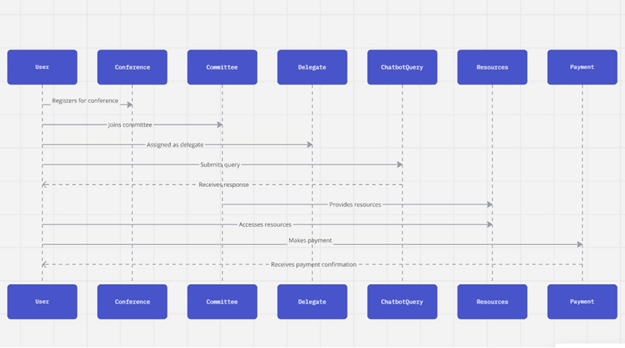

Screens
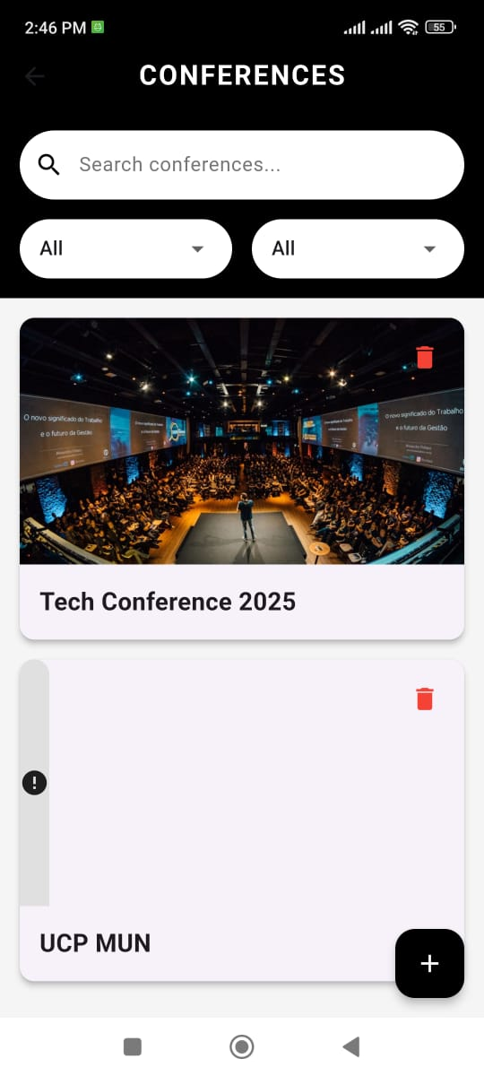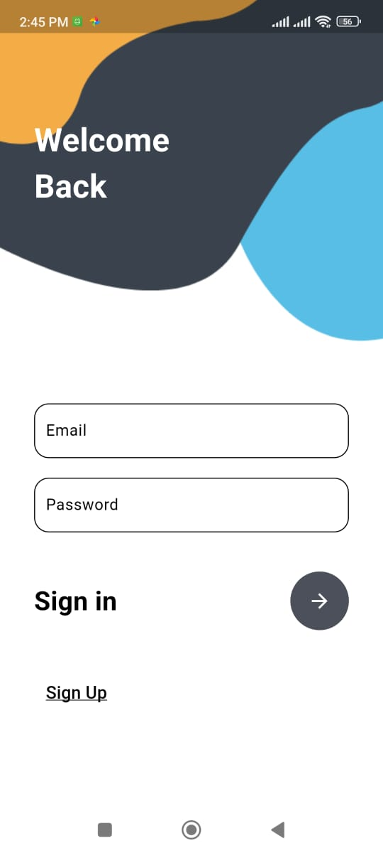
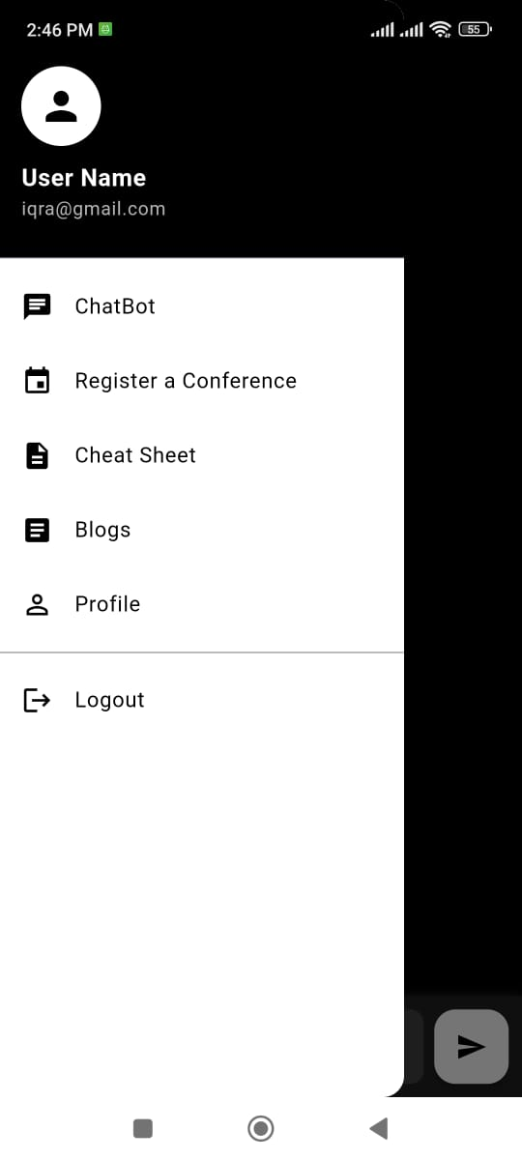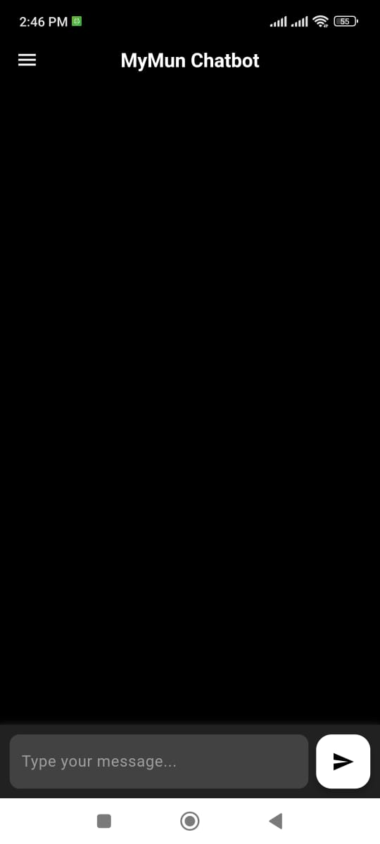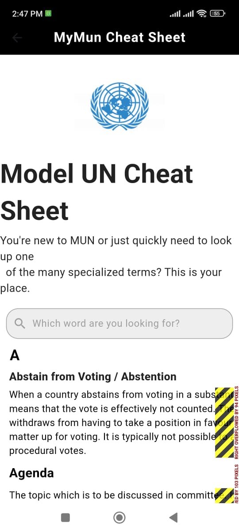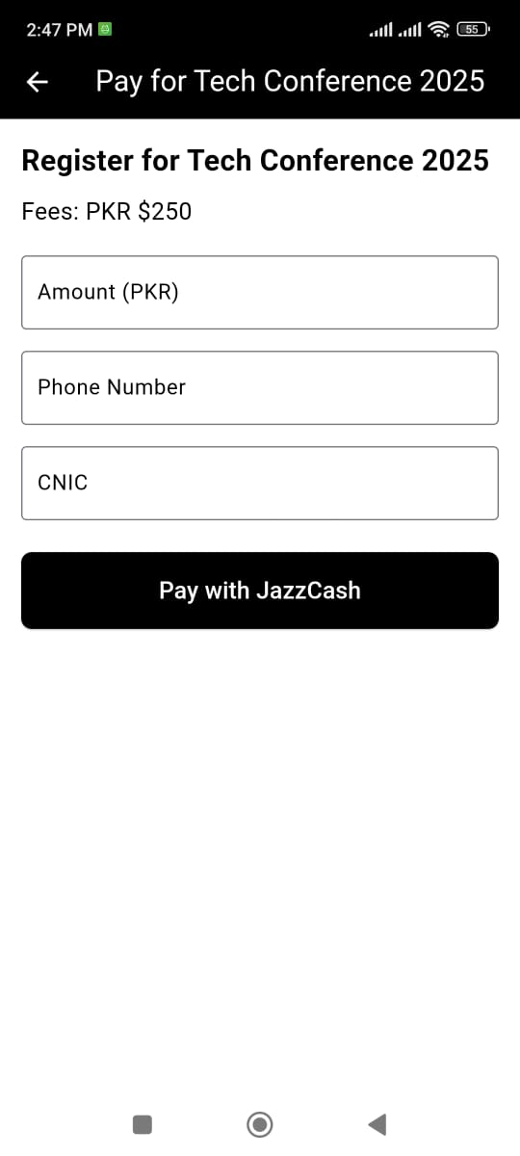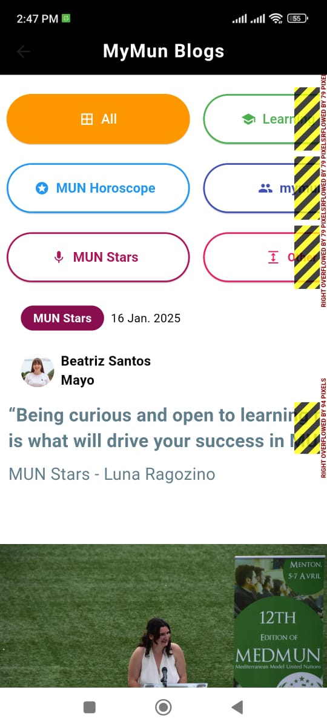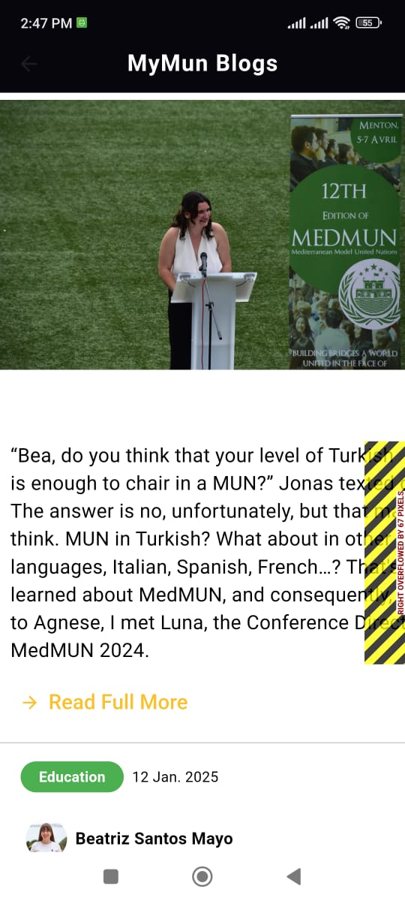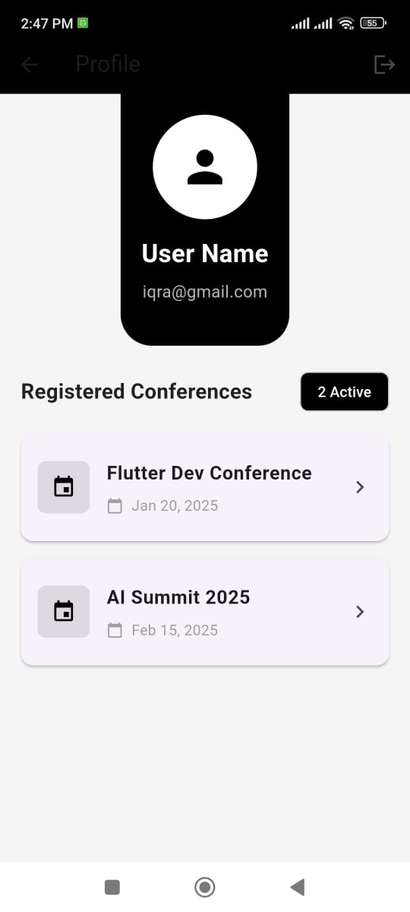

Additional Information
This app will be responsible for registering, paying and prep-ing for MUNs all over Pakistan.

Other Design Details
Resource Management for Conferences
Plan how resources like study guides, agendas, and country profiles will be managed and updated within the app.
Delegate Registration Process
Refine the flow for delegate registrations, ensuring a smooth and secure authentication system using Firebase.
Push Notification Implementation
Discuss the use of Firebase Cloud Messaging for timely updates on conferences, agendas, and other critical notifications.
Database Optimization and Scalability
Evaluate database architecture for efficiency in handling increasing user data and ensure scalability for future expansions.
Post-Launch Support Plan
Design a framework for post-deployment user support, including FAQ sections, chatbot assistance, and feedback handling.
Monetization and Revenue Streams
Explore options like premium features, advertising, and partnerships to ensure sustainable revenue generation for the app.
Educational Resource Curation
Discuss strategies for curating high-quality educational resources that cater to both novice and experienced MUN participants.

Test Specification and Results

Test Case Specification:
Table 6.1: TC-1
Identifier | TC-1
Related requirements(s) | User registration must be functional and secure
Short description | Test user registration functionality
Pre-condition(s) | User is not registered
Input data | User name, email, password
Detailed steps | 1. Open the app.2. Navigate to the registration page.3. Enter valid user details.4. Submit the form.
Expected result(s) | User account is successfully created, and confirmation is displayed.
Post-condition(s) | User is logged in or redirected to the login page
Actual result(s) | Pass
Test Case Result | Pass

Identifier | TC-2
Related requirements(s) | Users should be able to log in securely.
Short description | Test user login with valid credentials.
Pre-condition(s) | User has registered and has valid credentials.
Input data | Email, password.
Detailed steps | 1. Open the app.2. Navigate to the login page.3. Enter valid credentials.4. Submit the form.
Expected result(s) | User is logged in and redirected to the dashboard.
Post-condition(s) | User session is active.
Actual result(s) | Pass
Test Case Result | Pass

Identifier | TC-3
Related requirements(s) | Organizers should be able to create new conferences.
Short description | Test conference creation by organizers.
Pre-condition(s) | Organizer is logged in.
Input data | Conference name, dates, location, description.
Detailed steps | 1. Go to the dashboard.2. Click on "Create Conference".3. Fill out the form with valid data.4. Submit.
Expected result(s) | Conference is successfully created, and confirmation is displayed.
Post-condition(s) | Conference is added to the database and visible to users.
Actual result(s) | Pass
Test Case Result | Pass

Identifier | TC-4
Related requirements(s) | Delegates should be able to register for conferences.
Short description | Test delegate registration for a conference.
Pre-condition(s) | Delegate is logged in and has selected a conference.
Input data | Committee selection, delegate details.
Detailed steps | 1. Go to the conference list.2. Select a conference.3. Register for a committee.
Expected result(s) | Registration is successful, and confirmation is displayed.
Post-condition(s) | Delegate details are stored in the database.
Actual result(s) | Pass
Test Case Result | Pass

Identifier | TC-5
Related requirements(s) | Chatbot should respond to delegate queries.
Short description | Test chatbot query submission.
Pre-condition(s) | Delegate is logged in and assigned to a committee.
Input data | Query text.
Detailed steps | 1. Open the chatbot.2. Enter a query related to the committee.3. Submit the query.
Expected result(s) | Chatbot provides an appropriate response, and query is logged.
Post-condition(s) | Query-response data is stored for future reference.
Actual result(s) | Pass
Test Case Result | Pass

Summary of Test Results

Table 6.2: Summary of All Test Results
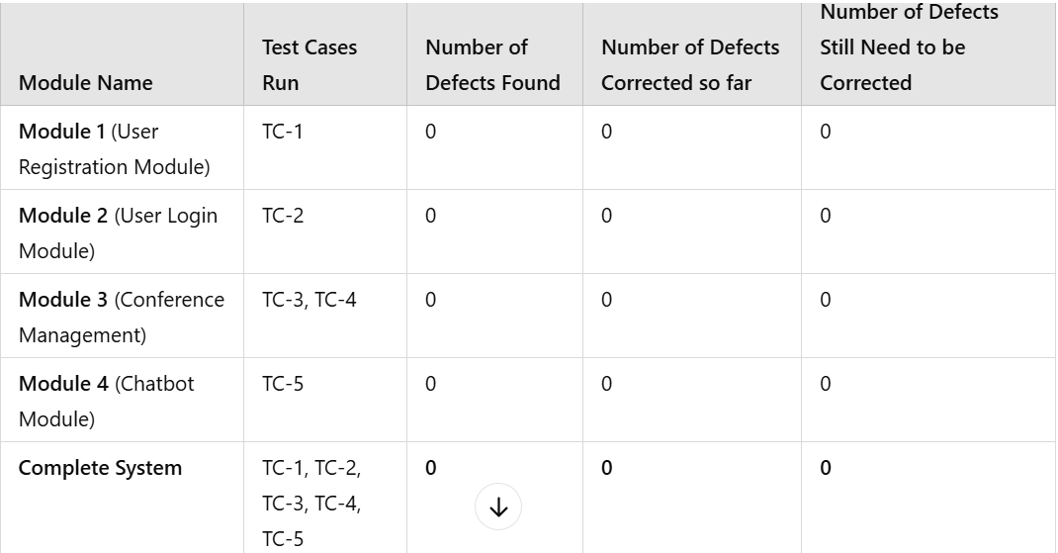

Table 6.2: Project Completion Status
Module Name | Status  (Complete, Partially Implemented, Not Implemented)
Module 1 (REGISTRATION) | COMPLETED
Module 2 (TABS OF CONFERENCE) | COMPLETED.
Module 3 (PAYMENT) | COMPLETED
Complete System | COMPLETED

Project Completion Status

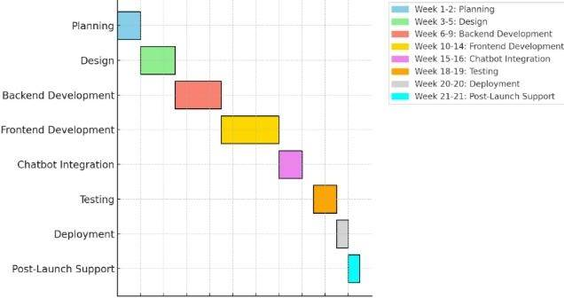

Table 7.1: Project Completion Status
Module Name | Status  (Complete, Partially Implemented, Not Implemented)
Module 1 (for example Bill Calculation Module, Speech Processing Unit | completed
User Authentication | completed
Test Initialization | completed
Complete System | completed

The Prep-MUN app has achieved significant progress on its objectives. Registration and payment processing have been fully implemented using Firebase, ensuring secure and seamless functionality. The chatbot feature has been partially completed, with basic query handling integrated while advanced features like multilingual support remain in development. Resources, including study guides and agendas, have been successfully uploaded and linked to their respective committees. Real-time notifications are fully functional, powered by Firebase Cloud Messaging. The app's core design elements are implemented, but some changes based on user feedback are pending. While initial testing has been conducted, comprehensive stress and regression testing are ongoing. Lastly, the business model discussions and monetization strategies have not been finalized yet, requiring further attention.

Table 7.2: Objective(s)/Target(s) Status
Target/Objective | Status  (Completed,  Partially Completed,  Not Completed) | Reason(s)
Delegate Registration System | completed | Fully implemented with Firebase for secure and seamless registration.
Chatbot Integration | completed | Initial version of chatbot integrated, but advanced query handling and multilingual support are in progress.
Conference Resource Management | completed | Resources such as study guides and agendas successfully uploaded and linked per committee.
Notifications for Updates | completed | Real-time notifications via Firebase Cloud Messaging fully functional.
Testing and Quality Assurance | completed | Basic testing is done; comprehensive stress and regression testing are still ongoing.
Monetization Strategy | completed | Business model discussions and monetization strategy implementation are pending.

Deployment/Installation Guide
System Setup
  - Hosting the Backend Server:
    - The Prep-MUN backend is hosted on a cloud platform such as Firebase for scalability and seamless access.
    - The backend server ensures real-time data synchronization, chatbot interaction, and database management.
  - Setting up the Server:
    - Install required dependencies, including backend APIs and Firebase for database management.
    - Secure backend communication using HTTPS to ensure encrypted data transfers (e.g., delegate registration and payments).
Application Configuration
  - Flutter Codebase Integration:
    - Clone the Prep-MUN app’s Flutter repository.

  - API Integration:
    - Link the app to the backend APIs and chatbot services by setting up the API keys in the app configuration files.
Deployment of Mobile Application
  - Build the APK:
    - Use Android Studio to generate a release APK for the app.
    - Ensure the signing key and build configurations are properly set up for distribution.
  - Upload to Play Store:
    - Prepare a listing on Google Play Store with app descriptions, icons, and screenshots.
    - Submit the APK for Play Store review and approval.
User Access
  - Share the Play Store link with users to download the app.
  - Provide login credentials for admins, chairs, and organizers through an onboarding email.
Testing
  - Conduct thorough testing before launch:
    - Validate features like delegate registration, chatbot interaction, and payment integration.
    - Ensure all user roles (admin, chair, delegate) have correct access levels.
Final Steps
  - Enable automatic app updates to deliver new features and security patches.
  - Create a troubleshooting guide to assist users in resolving issues like app crashes or login errors.

Access the App
  - Download the Prep-MUN app from the Google Play Store.
  - Login with provided credentials:
    - Delegates can access conference schedules, committee details, and study resources.
    - Admins and chairs can manage registrations, schedules, and chat moderation.
System and Backend Connection
  - Ensure the mobile device is connected to the internet for real-time backend communication.
  - Verify Firebase or backend services are reachable for features like chat and payments.
Using the App
  - Access features like delegate registration, conference schedules, and chatbot Q&A through the app interface.
  - Chairs can moderate community chats and access conference-specific updates.
Data and Result Management
  - Export conference reports or session data via the admin dashboard for documentation or sharing with stakeholders.
  - Use built-in help sections for step-by-step guidance on resolving common issues.
By following this guide, the Prep-MUN app can be successfully deployed, ensuring a smooth experience for all users.

User Manual
Login or Sign-Up Process
  - Sign-Up: New users are required to create an account by entering their email address, setting a secure password, and providing necessary details like their name and role (e.g., delegate, chair, or admin).
  - Login: Returning users can log in by entering their registered email and password. In case of forgotten passwords, users can reset them using the "Forgot Password" option.
Viewing and Registering for Conferences
  - After logging in, users will be directed to the Conferences section where they can browse upcoming or ongoing events.
  - To register for a conference, users must click on their desired event and fill out the required form fields (e.g., name, role, and committee preferences).
  - Registration details are designed to ensure all relevant information is collected for efficient event management.
Making Payments via Mobile Wallets
  - Once registered, users can proceed to pay their registration fees through integrated mobile wallet payment options.
  - The system supports popular digital wallets, ensuring convenience and secure transactions.
One-Time Password (OTP) for Payment Verification
  - To ensure secure transactions, an OTP will be sent to the user’s registered email or mobile number.
  - Users must enter the OTP in the app’s payment section to verify the transaction and complete their registration process.
Chatbot Interaction
  - The Chatbot feature is accessible to all users for quick assistance.
  - Users can send text-based prompts or questions related to the conference, such as schedules, committee details, or guidelines. The chatbot will provide instant responses or redirect users to relevant app sections.
This process ensures a smooth and user-friendly experience for conference registration, payment, and interaction, while maintaining secure and efficient workflows.

References
1.MYMUN
2.HMUN

Project Summary Form
Name of Project | Model United Nations App -- PrepMUN
Project Type | research
Department | Computer Science
Start Date | Click or tap to enter a date.
Completion Date | Click or tap to enter a date.
Supervisor / Team Leader | Arqam Altaf
Team Members (if any) | Hamza Basharat, Ahmer Akhtar
Funding Agency (if any) | none
Amount of Funding (if any) | None
Assign SDGs to Project | 4,5 and 16.
Motivation of Project | Keeping public speaking accessible to all.
Practical / Potential Application | PREPMUN
Abstract | Model United Nations (MUN) conferences serve as a platform for students to engage in debates and discussions about global issues, enhancing their public speaking, diplomacy, and research skills. However, students often face challenges in preparation due to the lack of accessible and organized resources. This mobile application aims to address this gap by providing a comprehensive solution tailored to the needs of the MUN community, particularly in Pakistan.  The proposed MUN Prep Mobile Application will be a first-of-its-kind platform designed to assist students in preparing for their competitions effectively. It will include features such as an AI-powered chatbot for query resolution, delegate registration, agenda-specific databases, payment gateways, and forums for community interaction. Additionally, it will offer curated resources to help users understand the topics and agendas across various MUN domains, such as Security Council, NGOs, and Press Committees.  As active participants in Pakistan's MUN circuit, we aim to create a tool that enhances accessibility, fosters engagement, and supports the growth of MUN culture within the region. By streamlining preparation and fostering collaboration among participants, this application has the potential to transform the MUN experience for students and organizers alike
Key Technical Features | Registration, Document uploading, Payments, Chat-bot.
Projects Images / Screenshots | 

Appendix A: Glossary
DFD: Data flow Diagram

ERD: Entity relational Diagram

SQL: Structure Query language

Appendix B: IV & V Report
(Independent verification & validation)
IV & V Resource

Name Signature

S# | Defect Description | Origin Stage | Status | Fix Time
 |  |  |  | Hours | Minutes
1
2
3
…
Table B.1: List of non-trivial defects

This document has been adapted from the following:
- Previous project templates at UCP
- High-level Technical Design, Centers for Medicare & Medicaid Services. (www.cms.gov)

